

Sahan Rathnayake
1916390

IMPLEMENTATION OF A MOBILE APPLICATION THAT HELPS USERS TO RELIEVE WORKPLACE STRESS AND IMPROVE MENTAL WELLBEING

BSc (Hons) Computer Science & Software Engineering

Undergraduate Thesis Report

Department of Computer Science & Technology
The University of Bedfordshire

Ms. Ruchira Manikka Arachichi

2020

Abstract

Modernized world seems to have encountered new health hazards than the old days which are not visible to the outside nonetheless are harmful for our physical and metal wellbeing. Among these, workplace stress is the most common and rapidly spreading one. A mobile application capable of relieving workplace stress came into the picture in the exigency of a solution for stress which can be afforded by everyone. So, the developed Happy Mind mobile application assist employees in easing out the daily workplace stress. Android studio is the application development environment, and the application is built using java as the language. The application is developed based on the concept of Artificial Intelligence. Since the workplace stress is emerging as a common threat to the society, many solutions have tested out among the employees from which are some mobile applications. These mobile applications do not meet the requirements for the best solution for workplace stress like Happy Mind application since it gives a personalized solution for the user unlike other applications developed so far. In other words, solution given by the application is unique to the relevant user which make the application more effective on relieving the workplace stress. So, upon the utilization of Happy Mind, chances of workplace stress subjugating employees will be diminished.

Acknowledgements

First and foremost, I would like to express my special thanks to university of Bedfordshire for letting me take part in this degree pathway.
Then I would like to share my deepest heartfelt gratitude to Dr Enjie Liu and Dr Gayana Fernando for all the course materials and guidelines given throughout this module. Next, my humble and sincere thanks goes to my research supervisor, Ms. Ruchira Manikka Arachichi for guiding and helping me down this road in successfully completing my research from the day one. Next, I would like to offer my special thanks to Dr Tess Crosbie for the session we received in the day one of this module.
Next, I would like to thank Google and Google Scholar search engines which helped me in finding the research papers and other documents needed for my research. Next, I would like to offer my big thanks to all the authors who have contributed to Stack Overflow and GitHub from which I received great assistance in developing the mobile application.
Then, I would like to thank my parents and my brother who helped me in successfully completing this research in a limited time frame.
Lastly, I am are overwhelmed in gratefulness to acknowledge all, who have guided and showed me the path in achieving all the objectives of the research by overcoming the obstacles.

Dedication

This research is wholeheartedly dedicated to my parents who have been my role models for my entire life. Thank you both for not giving up on me and supporting me in each and every way possible and for always having faith on me. They have been giving me the emotional, moral, and financial support all the time.
Next, I would like to dedicate this research to all my mentors at UOB and SLIIT.
Lastly, I would like to dedicate this project to all the hardworking employees out in the society who are trying their best to the make the world a better place regardless of their mental and wellbeing.

Key words

- Happy Mind application
- Artificial Intelligence (AI)
- Stressors
- Workplace Stress
- Employees
- Mood

Table of Contents

Abstract i
Acknowledgements ii
Dedication iii
Key words iv
Table of Contents v
Chapter One: Introduction 1
1.1.Background to the project 1
1.2.Project Aims and Objectives 2
1.3.Description of the artefact 3
1.4.Structure of the report 5
Chapter Two: Literature Review/ Market Research 6
2.1 Introduction 6
2.2 Workplace stress 6
2.3 Factors Causing workplace stress 7
2.4 Impact of workplace stress 11
2.5 Similar system review 12
2.5.1 Oiva 12
2.5.2 Happier Healers 13
2.5.3 Relax lite: Stress Relief 13
2.5.4 Anti Stress – Anxiety Relief Relaxing Games 14
2.6 Conclusion 15
2.7 Market Research 16
Chapter Three: Design of the Artefact 25
3.1. Requirement gathering 25
3.2 Feasibility Analysis 29
3.3 Artefact Design 29
3.3.1 Interface Design 29
3.3.2 System Design 31
Chapter Four: Implementation and Testing of the System 32
4.1 System Implementation 32
4.2 System Testing 37
Chapter Five: Evaluation 41
5.1 Functional Evaluation 41
5.2 Performance Evaluation 43
5.3 Test User Evaluation 44
Chapter six: Conclusion 50
6.1 Reliability / Accuracy of the system 50
6.2 Importance of the outcome 50
6.3 Limitations of the system and Recommendations 51
6.4 Future Work 52
References 53
Appendix A Project Poster 56
Appendix B UML Diagrams 57

List of Figures

Figure 1 High level system architecture diagram 4
Figure 2 Illustration of Work-related Stress Factors and Outcomes 10
Figure 3 Market Research question 01 pie chart 17
Figure 4 Market Research question 02 pie chart 18
Figure 5 Market Research question 02 frequency table 18
Figure 6 Market Research question 03 pie chart 18
Figure 7 Market Research question 03 frequency table 19
Figure 8 Market Research question 04 pie chart 19
Figure 9 Market Research question 04 frequency table 19
Figure 10 Bar Chart of Survey question 05 20
Figure 11 Market Research question 06 pie chart 20
Figure 12 Market Research question 06 frequency table 21
Figure 13 Market Research question 07 pie chart 21
Figure 14 Market Research question 07 frequency table 21
Figure 15 Market Research question 08 pie chart 22
Figure 16 Market Research question 08 frequency table 22
Figure 17 Market Research question 09 pie chart 22
Figure 18 Market Research question 09 frequency table 23
Figure 19 Market Research question 10 pie chart 23
Figure 20 Market Research question 10 frequency table 23
Figure 21 Market Research question 11 pie chart 24
Figure 22 Market Research question 11 frequency table 24
Figure 23 Mood tracker interface 34
Figure 24 Login interface 35
Figure 25 Registration interface 35
Figure 26 Feedback survey question 01 chart 44
Figure 27 Feedback survey question 02 chart 45
Figure 28 Feedback survey question 03 chart 46
Figure 29 Feedback survey question 04 chart 46
Figure 30 Feedback survey question 05 chart 47
Figure 31 Feedback survey question 06 chart 47
Figure 32 Feedback survey question 07 chart 48
Figure 33 Project Poster 56
Figure 34 Use Case diagram of the system 57
Figure 35 Sequence diagram for login function 58
Figure 36 Sequence diagram for activity suggestion function 59

List of Tables

Table 1 Mood stress data table 36
Table 2 User Feedback on system features 48
Table 3 User feedback on system improvements 49

Chapter One: Introduction

Background to the project

Before the 21st century people had issues with struggling to earn a living and needs and wants of them were simpler. But in this day and age, with the technological advancements, people have complicated their lifestyles with different needs and wants. Workplace stress is the modern health hazard which affects the work-life balance of employees and badly affects the organization. Stress has a direct relationship between an employee and the environment they work in. And stress is built up when the demands exceed the abilities of individuals causing threats to their comfort and convenience (Beheshti and Hajizadeh, 2013). According to Health and Safety Executive (2004) job stress can cause severe mental disorders, anxiety, depression. Therefore, it was crucial to introduce solution in reducing workplace stress.
The developed system is an artificially intelligent smart mobile application that helps users to relieve workplace stress and improve mental wellbeing. This application was mainly targeted to employees who work stressfully and in need of ways to help reduce the stress and take control of the mental wellbeing. So, this is basically a digital workplace wellbeing program which will be focusing on mental health.
The developed system provides a better and effective solution to one of the biggest medical challenge, mental illness which is caused by workplace stress. This application is really helpful for the individuals who are suffering from work stress and need assistance. Through science and technology users are empowered to take control of their physical and mental wellbeing which brings positive state of mind plus body along with upbringing the physical health.

Project Aims and Objectives

Aim

- To develop a mobile application with Artificial Intelligence techniques for relieving workplace stress of employees.

Objectives

- To identify and evaluate existing stress relieving techniques and to identify Artificial Intelligence techniques suitable for relieving workplace stress
- To develop a system to monitor user behavioural patterns.
- To develop a personalized dashboard to display well-being score of the user.
- To develop an Artificially Intelligent system to suggest personalized stress relieving activities based on past user experience.
- To develop a chatbot as an application guide to the user.
- To evaluate the developed Artificially Intelligent application and test it on a selected group of users.

Description of the artefact

The developed system is an AI powered mobile application helps users to understand the sources of stress and teaches the users to cope with it and control it. Unique insights to the user’s mental wellbeing are provided by the application by tracking psychometric and behavioural data of the user. Application continuously monitor health data to provide the user with a wellbeing score, in real-time.
Mood data of the user is tracked by the application which is used to analyse stress level of the user. Dashboard is used to display all the analysed stress data of the user. And the improvements in stress relieving can also be accessed in the dashboard. All the stress relieving activities are suggested through artificial intelligence. Hence the suggesting patterns are unique to the user. A chatbot is also designed to the system which is used to get to know about the user quickly. Since the implementation of a chatbot, user experience is pleasant and entertaining.
Features of the system,
- Mood Analyzer
Everyday mood of the user is tracked with the use of set of emojis.
- Personalized Dashboard
A real-time wellbeing score is displayed in the dashboard and stress level comparisons over the days of the week is also displayed in the dashboard. Users’ progress in controlling stress is also displayed in the dashboard.
- AI powered stress relieving activities suggesting system
Application uses artificial intelligence to suggest stress relieving activities based on the past data of the user. System learns about the user day by day and activities suggested are unique to the user.
- Chatbot
A chatbot was integrated to the system to guide the users in handling the application and to understand the user.

The flow of the system mentioned in the following high-level system architecture diagram.
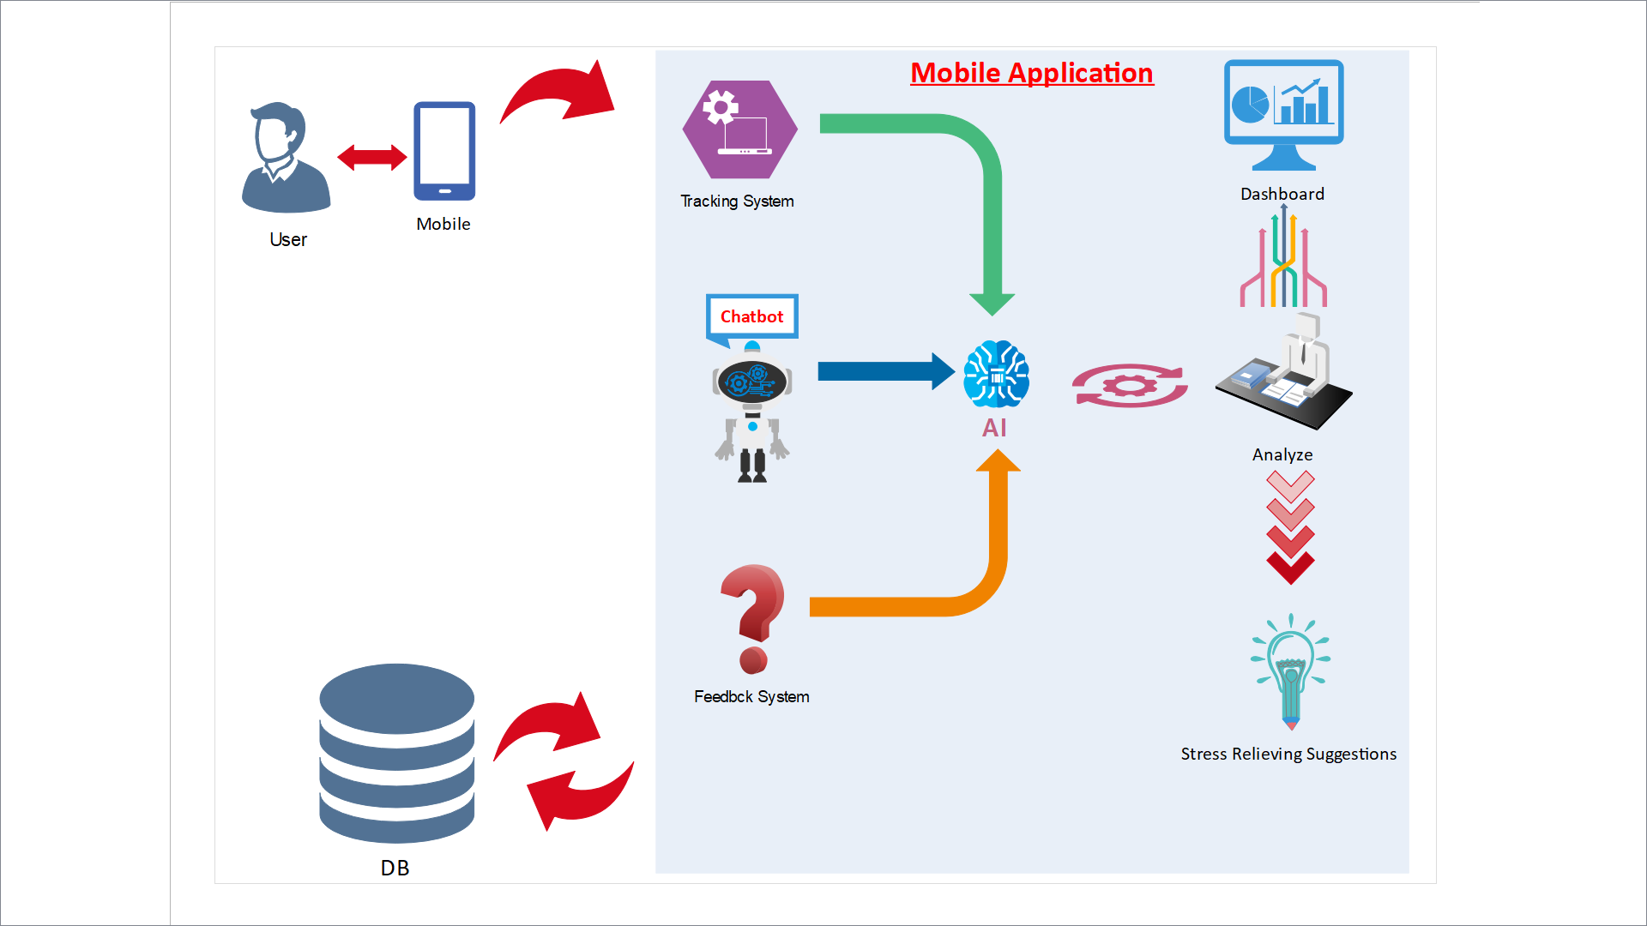
Figure 1 High level system architecture diagram

Structure of the report

Chapter one: Discusses about the background study of the research. Also includes the aim and objectives of the project. Furthermore, artefact is described in high level.

Chapter two: Contains the properly done literature review and the market research data.

Chapter three: Artefact design is discussed in this chapter. Design is discussed under interface design and the system design.

Chapter four: Development and testing of the system is illustrated in this chapter

Chapter five: Critical evaluation of the system is done in this chapter. Functional and performance evaluation done by the researcher is included in this chapter. Apart from that test user evaluation also added to this chapter

Chapter Six: Conclusion of the research is discussed in this chapter. Accuracy levels of the system and importance of the developed system are added to this chapter. Limitations, recommendations and future work also included in this chapter.

Chapter Two: Literature Review/ Market Research

A proper literature review linked to workplace stress, the impact of it on the society and to individuals and the solutions given so far will be provided in this section. The importance and the reasons for the researcher to undertake the research is highlighted in this section.

2.1 Introduction

All the areas required for the research of workplace stress are covered in this literature review. Workplace stress, factors affecting workplace stress, Impact of the workplace stress on the society and solutions for it is discussed under the literature review. The latter part of this literature review concentrates on the similar systems which are critically evaluated.

2.2 Workplace stress

The force applied on an object to result in damage, breaking or bending is a simple definition given to the term stress in physical science. Any unfavourable or favourable demands placed upon human beings can cause the human body to respond to them which is the stress of human beings. An individual will be put in a stressful condition when the requirements of a situation or the pressure caused by the particular situation is too wide for them to handle. Prolong continuation of these stressful conditions can cause physical, mental and behavioural damages (Mansoor et al., 2011). Diverse organizational and behavioural studies confirm that workplace stress has become a universal phenomenon which is raising unpropitious health conditions. Colligan and Higgins (2006) claim that without a proper understanding of stress, as the “parent construct” workplace stress can be a very complicated scientific construct. Mcgrath (1976) defines stress as environmental instances where an individual is expected to accomplish tasks with limited resources provided that are beyond the skill level of the individual. He further states that in doing so that particular individual expects a big reward for the task.

In the present world occupation is one of the most significant sources of stress (Eremsoy, Çelimli and Gençöz, 2005). In the perspective of Peter and Siegrist (2000) incompatibility between the demands at work and the abilities of the employee can trigger work stress. Works stress obtained significant attention in psychological studies. It was renounced as one of the plagues of the 20th century by the United Nations in 1992, and later WHO introduced it as a widespread global issue (Tangri, 2003).

2.3 Factors Causing workplace stress

The occupational life of each and every employee can be affected by various stressors, factors causing stress which impact on their work-life balance exerting a severe amount of psychological pressure on their mind. Studies have indicated that occupational-related factors can influence on physical, mental and behavioural health. Beheshti and Hajizadeh (2013) state that certain work-related advancements like changes in salary incomes, organizational structure improvements, new recruitments and layoffs can endanger individuals to the pressures of all sorts leaving them depressed, confused and stressed out. Further, they point out that intense amount of work, time pressures, skill imbalance can terribly damage the mental health of an employee. Work stress is due to different aspects of an organization, over time, lack of support from the organization, high demands with a lot of pressure, lack of help provided by colleagues and supervisors (Mansoor et al., 2011).

Stressors act as agents which initiate various stress reactions. Some work-related mental stressors are pleasant while some are not pleasant. For example, a job promotion can be really stressful just like a layoff. According to the thebmj (1996) website stressors can build up which is why they often found to be additive. A single stressor can trigger a chain of other stressors if remedies are not utilized. Thebmj (1996) point out the following factors to be the leading stressors causing workplace stress.

- Workload
- Poor posture
- Monotonous tasks
- Night shifts
- Overtime
- Fear about sanctions
- Happiness about promotion
- Anger due to injustice
- Challenge for a new position
- Competition with colleagues
- Conflicts with colleagues or managers
- Negative thoughts about work self
- Time pressure and deadlines

The figure mentioned below is an illustration of work-related stress factors and outcomes modelled by Michie (2002). Different types of stressors are grouped into main categories as represented below. First types are the factors that are native to the job role. Work overload is a very common stressor among all the factors. Deadlines and time pressures are also related to the job role and can vary according to the job role. Poor working conditions and lack of job control also comes with the job role. Over promotion, under promotion, not getting job security and layoffs can arise with the development of the career. Role stress, role uncertainty, conflicts within the roles are also considered as stressors which are the roles within the organization. Workplace relationships also a leading factor in a stressful working environment. Not having a good leadership, bullying, discriminations due to various reasons lead to unhealthy work relationships. Constant changes in the organizational structure also affect the workplace stress. Decision making, participation, management style variations are leading factors among these. Ultimately all of these factors lead to physical and mental health issues, burnouts, high turnovers, job strain and poor performance among individuals of the organization. This is going to affect badly to the employee and to the organization itself.

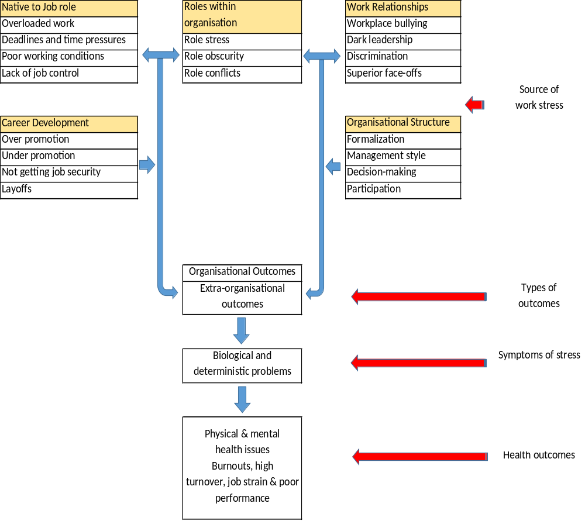

Source: (Michie, 2002)

Figure 2 Illustration of Work-related Stress Factors and Outcomes

2.4 Impact of workplace stress

The three physical, mental, and social dimensions are all together can be stated as health which is a multidimensional concept. Human health can be jeopardized due to stress, causing to collapse in physical and mental status. Getting exposed to work-related stresses for long periods of time can result in burnouts (Beheshti and Hajizadeh, 2013). Kawakami and Haratani (1999) state that repeated and the long-term severe stress levels can impact negatively on employees’ physical and mental health. According to the Health and Safety Executive (2004) approximately half a million people in the United Kingdom are suffering from ill conditions due to work-related stress conditions. And furthermore, around 5 million feel “severe” or “extreme” levels of workplace stress and the society spends around £3.7 billion every year due to stress conditions (Yadegarfar et al.,2010). The stress studies carried out in Iran showed the existence of high levels of workplace stress to be about 14.4% (Embriaco et al., 2007). Mathee et al. (2010) concluded that about 70% of employees observed at their occupations had indications of stress or tension which was estimated by the American Academy of Family Physicians. Moreover, it is stated that 30% of employed society affected by the work stress in developed countries, where these numbers increase drastically in developing countries (Mathee et al., 2010). Tangri (2013) states that the depth of the job stress situation is well acknowledged for an instance in the United Kingdom about 13.5 million work operation days were wasted due to depression, anxiety and job stress in 2007/2008. Going further, 3.5% of the Gross Domestic Product (GDP) of each country were utilized for job stress-related problems according to the International Labor Organization (ILO) (Beheshti and Hajizadeh, 2013). These shocking numbers explain how much of a plague that workplace stress has become to the world and individuals.

According to Beer and Newman (1978), mild mental disorders prevail in individuals suffering from high levels of work stress. Further, they state addiction to drugs, neglecting work, reduced motivation is common among stressed people. In extreme levels of work stress employees tend to pay disinterest in work or frequent absenteeism or quitting their job completely (Johnson et al., 2005). Common health hazards like smoking, skipping meals, alcohol consumption, excessive caffeine addiction can be identified in stressed-out employees. So, it very much clear that workplace stress impact severely on society.

2.5 Similar system review

2.5.1 Oiva

Oiva is a mobile application designed to train mental wellness. The application was targeted for working-age individuals. This mobile application was designed on the basis of acceptance and commitment therapy (ACT). This application uses several stress relieving activities like mindful sitting, mindful breathing, mindful listening. When an individual is feeling stressed that stress can be reduced by following the activities that are generally displayed in the application.
This application takes the users generally and suggest the stress relieving activities. So, the user has to decide which activity is the best solution for stress.

2.5.2 Happier Healers

Medical students proven to have higher rates of depression, anxiety or stress than the general population. Meditation programs are often used as remedy for stress related situations and proven to have high accuracy rates than any other programs. So, this mobile application is basically an audio-guided mindfulness meditation program. This application guides the users to follow a meditation program whenever they feel stressed-out. Users can access the program through an audio guided feature.
Although meditation is a very effective stress relieving activity it might not suit some users. So, the application is limited to a meditation program and doesn’t give a common solution to all of the stressed-out individuals.

2.5.3 Relax lite: Stress Relief

This is a rapid stress relief mobile application. This application is designed with guided breathing and meditation exercises which promote relaxation by the calming music used in the background. This is a very simple mobile application. This mobile application contains following features.
A structured breathing courses
Eight-minute guided meditation session
Quick start

This application also limits to a breathing activity and a meditation program. Some users might not response to these activities.

2.5.4 Anti Stress – Anxiety Relief Relaxing Games

This mobile application is a collection of different relaxing games. It allows users to complete challenges and get rid of the day to day stress. So, this is an entertaining application which is managing stress through fun related activities. Some games that can be seen are,
Card games
Piano games
Fidget spinner games
Knife hit games

The game features that can be seen are,

Brain exercise and relaxation
Mind freshness activities
Relaxing sounds
Smooth controls

This also a good approach to reduce stress but still it is limited to gaming activities. Therefore, it does not provide a common solution to stress situation of users.

2.6.5 Stress Management – Effectively Reduce Stress

This application contains a e book about ways of effectively reducing stress. Basically, users need to go through chapters and understand the stress levels by diagnosing their symptoms. Then the factors causing the stress and different ways of reducing stress. This e book will contain tips and tricks on how to cope with stress and how to deal with it. This application contains,

Methods of responding to stress
Steps in stress management
Ways of reducing stress

So, this is application requires a lot of users’ time to read and understand the e book. And time is very crucial for an employee leading a busy lifestyle with tight schedules. And even after reading the e book knowledge gained can vary from user to user which can cause in the effectiveness of the application. That is drawback identified in this application.

2.6 Conclusion

Since workplace stress is a very common health hazard in present society, various solutions are introduced in order to control it. Mobile application as a solution also can be seen among these. In reviewing the mobile application introduced so far it is clear that those applications are very immature and simple in functioning. These mobile applications contain various limitations and drawbacks. Set of stress-relieving activities just included in an application is the most common scenario. These activities can contain a breathing exercise, meditation program, listening activities. Another common scenario is the anti-stress games. All of these grant solutions in general which is not an effective way since mental health is a very personalized matter and the situations can vary from user to user.
As discussed, giving a general solution is not the most effective way of reaching the stressed-out employees. With a dumb application, this challenge can never be achieved. Therefore, what it needs is a smart mobile application which can take decisions of its own according to the needs and requirements of the user. This can only be catered by introducing a mobile application powered by artificial intelligence (AI). Using AI, the application will decide which anti-stress activity is effective to which user. And user’s behavioural patterns play a major role in stress-related situations. If these behavioural patterns are not tracked, it is impossible to analyse the stress level of users. If the application is going to be successful, the user is going to need a place in the mobile application to view their stress levels and their improvements in stress conditions. With the development of a chatbot, users pay a more tendency to interact with the application on a daily basis.
Since all of these mentioned features are integrated into the developed system, it is a more effective and efficient application. Since workplace stress is one of the main threats to society and the developed system brings positive results in reducing the said threat it was very crucial that such a system is developed and released among the stressed-out employees.

2.7 Market Research

A market research was conducted by the researcher to further study on the importance of proposed research and the situation of workplace stress in the current society. A survey of selected questionnaire was passed on to 780 employees of different industries to gather the data. Then the gathered data was analysed using IBM SPSS Statics software.
For the survey to be more accurate, individuals were selected from different industrial fields. As shown in the below figures several industrial fields were chosen.

What industry do you work in?
  - IT industry
  - Health and medical care
  - Education / Academia
  - Engineering
  - Technical
  - Service
  - Other:
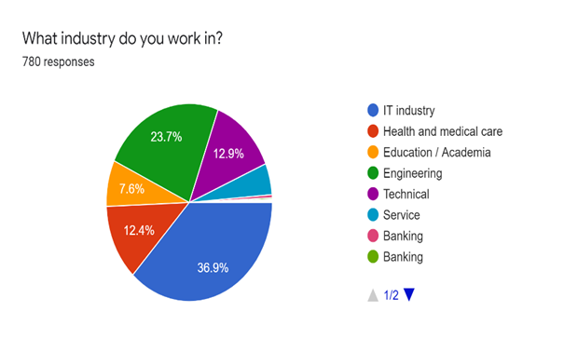
Figure 3 Market Research question 01 pie chart

Job satisfaction is negatively affected by work stress (Yahaya et al., 2010). So, the survey was used to analyse how much of a satisfaction employee have towards their jobs. More than 70% of the selected employees did not seem to like what they perform at their work.

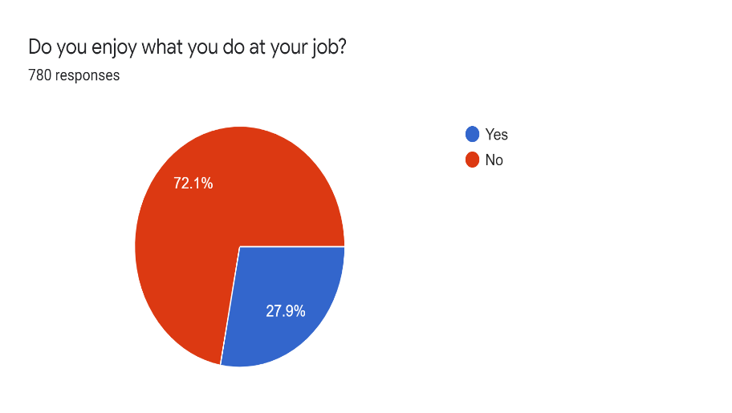
Figure 4 Market Research question 02 pie chart

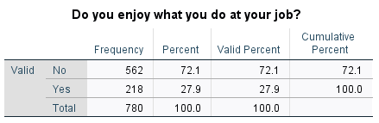
Figure 5 Market Research question 02 frequency table

Next the survey was focused on how the employees feel about their stress levels. Among the 780 individuals more than 80% are feeling stressed at work 54% of these stress levels are severe.
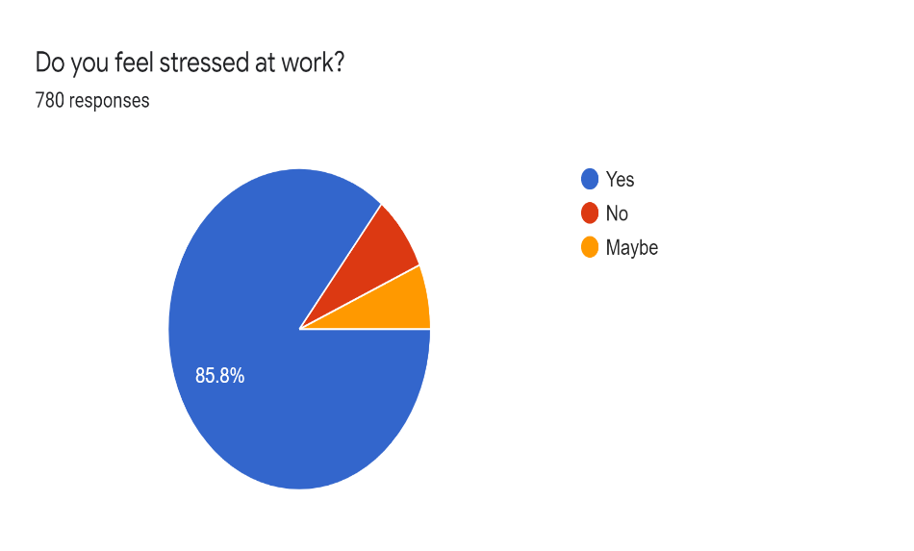
Figure 6 Market Research question 03 pie chart

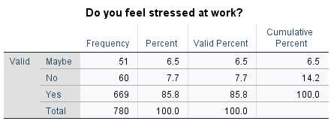
Figure 7 Market Research question 03 frequency table
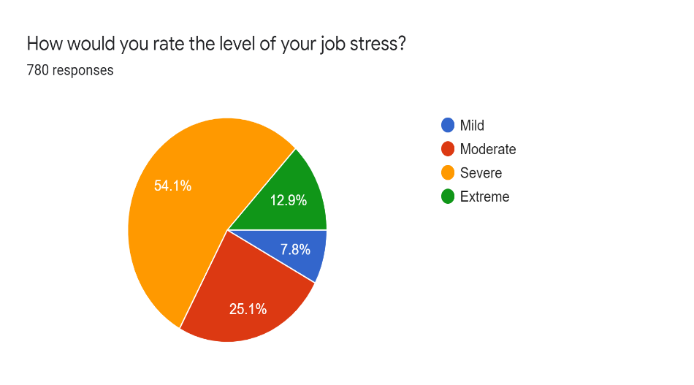
Figure 8 Market Research question 04 pie chart

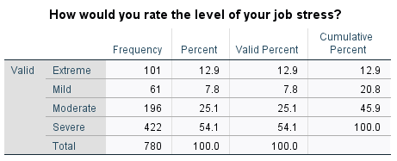

Figure 9 Market Research question 04 frequency table

Among the factors affecting work stress following factors seemed to be common according to the employee point of view. Workload and time pressures affect most of the employees as shown in the below figure

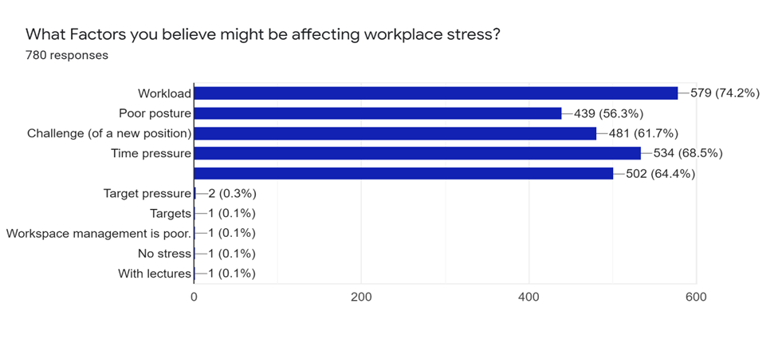
Figure 10 Bar Chart of Survey question 05

When the employees are always demanded to perform well in their profession the stress levels rise. Below figures illustrates that about 80% is always expected to perform well at work
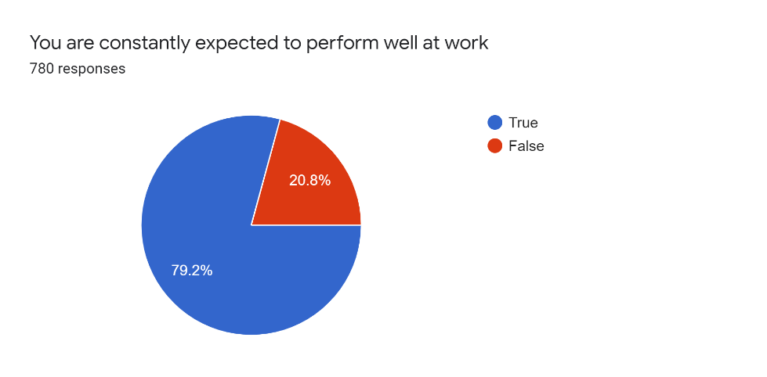
Figure 11 Market Research question 06 pie chart

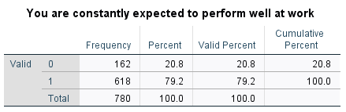
Figure 12 Market Research question 06 frequency table

Workload pressure on an individual increase drastically when targets are provided which are impossible to achieve on time and when the employee has no control over the assigned work. Out of 780 employees majority agreed to be had no control over the assigned work and workload is too much on them
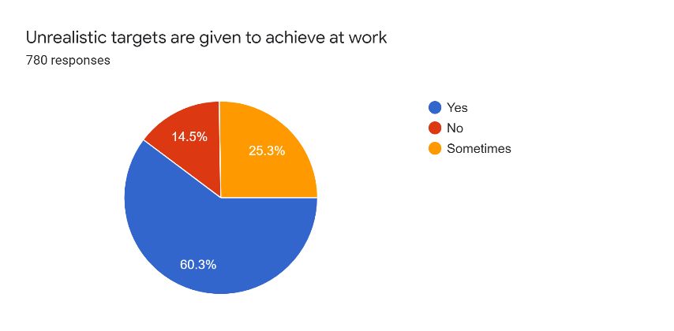
Figure 13 Market Research question 07 pie chart

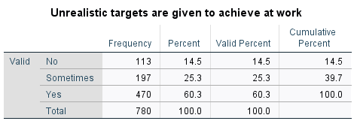
Figure 14 Market Research question 07 frequency table

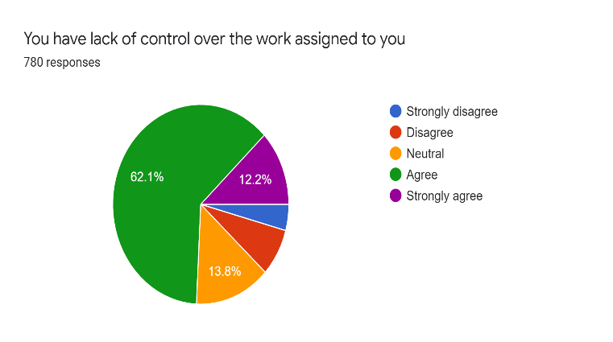
Figure 15 Market Research question 08 pie chart

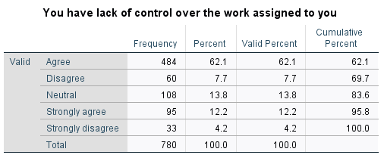
Figure 16 Market Research question 08 frequency table

Studies have confirmed that constant work postures can affect badly in physical health of employees which ultimately leads to mental stress conditions. According to the results pf figures attached below most of employees, above 70% are working in a constant posture.
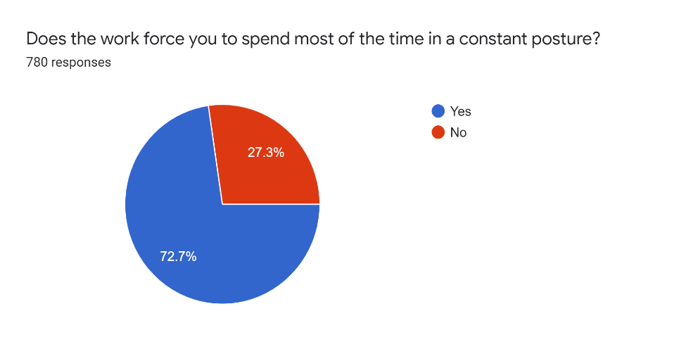
Figure 17 Market Research question 09 pie chart

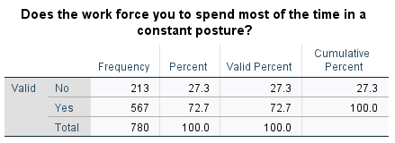
Figure 18 Market Research question 09 frequency table

Relationships maintained at the workplace also determine stress levels of employees. According to the survey half of individuals happened to have a neutral relationship with co-workers and sometimes they tend to have arguments with supervisors and co-workers

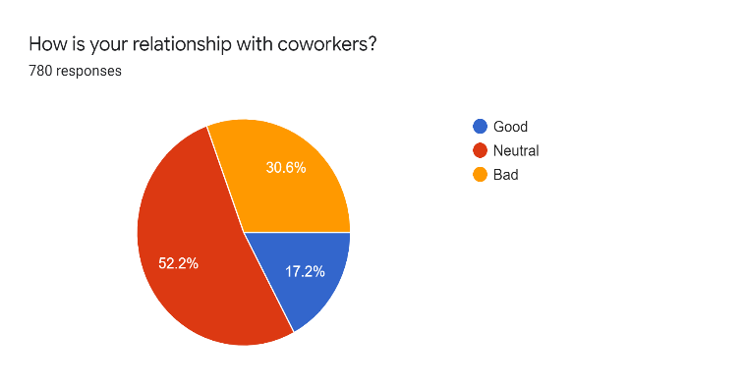
Figure 19 Market Research question 10 pie chart

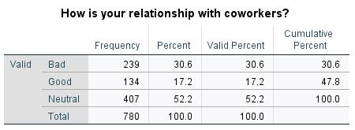

Figure 20 Market Research question 10 frequency table

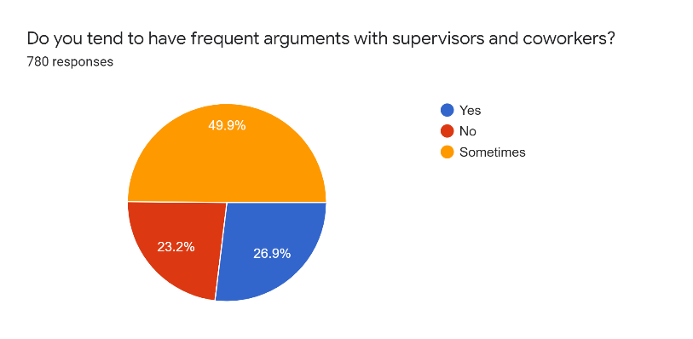
Figure 21 Market Research question 11 pie chart

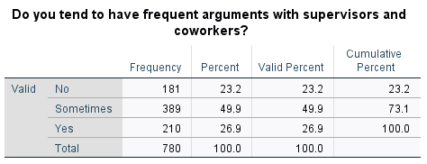
Figure 22 Market Research question 11 frequency table

Chapter Three: Design of the Artefact

3.1. Requirement gathering

Main motivation to carry out a research related to workplace stress was current situation of the world in occupational environments. Workplace stress has become a threat to the developing world and to the people who engage with the society. Hence, conducting a research on this field of study seemed to be important more than ever. For a proper research to be conducted, first requirements for a solution regarding the research filed needed to be laid out. In the field of workplace stress following main requirements were pointed out.

- Suggested solution needs to be cheap and can be accessed easily
- Need to keep track on the daily behaviours of the users
- Need to analyse the daily stress levels of the users
- Need to keep track of the past stress data of the users
- Need to understand the user
- Need to remind the users of the ways of relieving workplace stress
- Need to educate the users of the drawbacks of high stress levels
- Need to secure gathered stress level data of the users

Suggested solution needs to be cheap and can be accessed easily

This proved to be the most crucial requirement of this field of study. The known solution for stress from the old days is therapy which cannot be afforded by everyone due to financial problems and inability to allocate time for therapy sessions. Due to these mentioned issues most of the stressed-out individuals tend to ignore the stress. This tendency is significantly increased since the symptoms of stress does not usually appear physically. So, this prevents them from reaching out to a therapist and seek help. So, the suggested solution for the so-called workplace stress needed to be cheap and can be easily accessed. It needed to be with the user all the time which motivate them to seek help from it.

Need to keep track on the daily behaviours of the users

For the users to get a clear insight of their mental wellbeing it is required for them to have a good way of tracking the day today mood of the user. It is a proven fact that stress can be analysed by the mood of a person. Mood is directly affected by the stress of a person. Mood of a stressed-out person is almost all the time found to be unpleasant. Due to the busy schedules of the employees, they cannot memorize their moods by themselves. Since help is needed and a good mood tracking method is essential to analyse the stress levels of the employee. If this mood tracking method is going to be executed by an external mechanism, it needs to be seamless without irritating the user even more.
Need to analyse the daily stress levels of the users

The user’s ultimate requirement is to get an idea about current stress levels. For this to be fulfilled there should be an appropriate way to analyse the recorded mood data. These analysed data should be graphically displayed so that the user can get a clear understanding of the current mental condition.

Need to keep track of the past stress data of the users

Users want to access their pat data regarding stress levels to get an idea of their progress of stress management. By keeping the past records of the employees, they can compare the current stress levels with past stress levels and continue on the stress management activities. Being able to view their progress, makes the employees more motivated in using the developed solution.

Need to understand the user

This is also an important requirement of this research. Each user is different from one another. Individuals among the world have a diverse amount of likes and dislikes. Each person has a unique lifestyle which makes it hard to predict their behaviour. Due to this all the solutions provided for the workplace stress are tailored in the basis of a common assumption which is proven to be unsuccessful. Stress is a personalized matter which also require a personalized solution. Considering all of these factors, getting a good understanding of the user before providing the solution is required. Therefore, provided solution is unique to the user.

Need to remind the users of the ways of relieving workplace stress

Just providing a solution when the user feels stressed is not a complete way of relieving workplace stress. User should be constantly made aware of the stress relieving techniques. User should be given information about workplace stress and how to avoid it when necessary.

Need to educate the users of the drawbacks of high stress levels

Most common reason why the workplace stress is rapidly spreading, and precautions taken are less is employees are unaware of the bad impacts of the workplace stress. Due to this unawareness employees tend to neglect their stress levels and continue with their usual lifestyle. To prevent this matter, employees need to be properly educated about the bad impacts of the workplace stress.

Need to secure gathered stress level data of the users

These stress levels of user are personal data and need to prevent other parties from accessing them. For this it is necessary to make sure that these data can only be accessed by the user.

3.2 Feasibility Analysis

This analysis was carried out to test whether the gathered requirements are feasible to develop into a system. Since the system needed to cheap and easy to access, best solution was developing a mobile application to relieve workplace stress. Since in the present world, almost everybody has access to a smartphone, developing a mobile application was the best way of introducing solution for workplace stress which also meet the required demands. Since the application needed to smart than any other ordinary application, AI techniques needed to be used.

3.3 Artefact Design

3.3.1 Interface Design

Mobile application was designed to have different interfaces. Planning the interfaces prior to the implementation made the system flawless. First interfaces were identified, and a plan was set on the interface design. Below mentioned interfaces were identified as the main interfaces of the system.

- Login interface
- Registration interface
- Mood tracker interface
- Dashboard interface
- Chatbot interface
- Anti-stress activity suggesting interface
- About us interface

Login interface

This interface was designed with two text fields to enter Account Name and the Password. A button was added to submit the entered details. Another link was added to navigate to the registration interface.

Registration interface

This is the interface used to add the user information to the system. There is a text field to add the Account name and another two text fields to enter password and confirm the entered password. And a button is added to submit the entered information.

Mood tracker interface

This was a very important interface of the system. User’s mood data needed to be tracked by this interface. For this, instead of displaying user with a set of questions, a set of emojis was displayed which makes it more user attractive.

Dashboard interface

This is data displaying interface which picks up user attraction. Data needed to be displayed in a readable manner. Analysed stress levels are displayed in this interface.

Chatbot interface

This is the interface where the users get to interact with the application. This needed to be a simple interface with a chatting screen.

Anti-stress activity suggesting interface

This is a combination of multiple interfaces. Each activity takes a separate interface. Interfaces are different from one another.

About us interface

This screen was used to display the user with information of the developer. If the user needs to contact the developer regarding any issue, all the necessary contact details are displayed in this interface.

3.3.2 System Design

System design was done to implement a sketch on how the different interfaces interact with each other in the system. UML diagrams were designed to illustrate the system design more accurately (see Appendix B).

Chapter Four: Implementation and Testing of the System

4.1 System Implementation

The developed system is an android mobile application. Different tools were used to develop the Happy Mind mobile application. To refer to the designed poster see Appendix A

- Android studio 3.0.1
- Java
- Jdk 1.8.0
- SQLite
- Genymotion android emulator

The mobile application is developed using the android studio development environment. Java and jdk tools were used to build the system. SQLite was used as the database to the mobile application. Application is executed while in the development phase using genymotion android emulator.

Application was developed as module wise which made it easy to link the modules to each other. Following listed function were identified as the main function modules of the mobile application

- Mood tracker function
- Login and registration function
- Dashboard function
- Stress reliever system
- Chatbot

Mood tracker function

One of the main and important functions of the system. This function handles the behaviour of the user. Mood of a person is directly linked to the stress level of that person. Therefore, this function is used to determine the stress levels of the user. If the application needs to know the mood of the user, application probably wants to direct some questions to the user. But this method is found to be irritative and user might stop using the application. Instead of a set of questions nice and simple emojis are displayed to the user. This made the user experience more pleasant and it was easy for the application to track the mood of the user. Different mood used in the application are,

- Happy
- Sad
- Angry
- Sleepy
- Disgust
- Fear
- Neutral
- Surprise

Every time user interact with the application mood tracker will record mood data of the user as shown in the below figure.

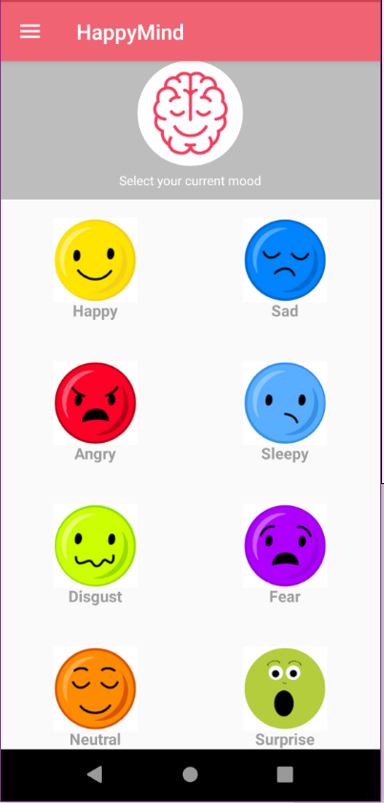
Figure 23 Mood tracker interface

Login and registration function

First time using the application user need to register to the application by creating a new account. By filling out the registration details user can create an account easily. The details of the user are stored in the database. User cannot create an account under the name of a previously created account. User should use an account name between 4 – 18 symbols. Password also should be in between 4 – 18 symbols. After successfully creating an account user can login to the system by entering the account name and the password.

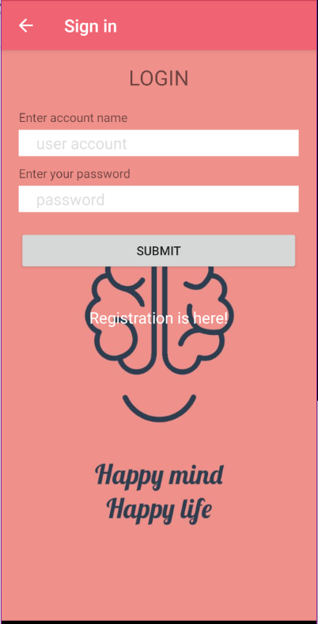
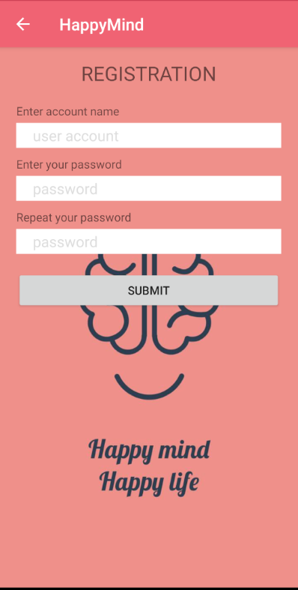
Figure 24 Login interface
Figure 25 Registration interface
Dashboard function

Dashboard is used to display the analysed stress levels of the employee. It is the interface where user can view their current stress levels. Incrementing and decrementing of the stress with regard to the mood is calculated according to the following table values.

Table 1 Mood stress data table

Mood | Stress increment/Decrement
Happy | Stress - -
Sad | Stress +
Angry | Stress ++
Sleepy | Stress ++
Disgust | Stress +
Fear | Stress ++
Neutral | -
Surprise | Stress +

Stress is not a bad feeling when its is in the normal level. But due to the different moods mentioned in the above table, stress levels can vary according to the relevant values. When the user enters the mood data through the mood tracker current stress level is updated accordingly and displayed in the dashboard. Dashboard is displayed only after the user login to the system since these data are personal.

Stress reliever system

This is the implemented function where the user is provided with the solution. Solution is decided by the application according to the stress level of the user. Following activities are suggested to the user,

- Breathing activity
- Listening to music
- Meditation activity
- Counting from 10 – 1

Chatbot

This is the function where user can interact with the mobile application. User can ask predesigned questions from the application to get a better understanding about the system. Through the chatbot, application records users likes and dislikes. Application can understand the user in a quite effective way when the user is interacting with the application. User awareness program of the impact of workplace stress is also carried out through the chatbot.

4.2 System Testing

Proper system testing was carried out to make the system functions smooth and effective. Each module was tested separately for high efficiency. Following scenarios are some of those test scenarios.

First scenario was carried out to test the login function. User directing to home page when the correct credentials were given in this test scenario.

Test  Case  ID | Test scenario | Test Steps | Test Data | Expected Result | Actual Result | Pass  /Fail
TC_01 | Check the user  login with valid credentials | 1. Click on the login section  2.Type account name  3.Type password  4.Click on Submit button | Account name = Admin  Password = 1234 | User should be navigated  to home page | As expected | Pass

Next scenario was to test the registration function. User should be able to register a new account to the mobile application successfully. This scenario was tested by the following test case.

Test  Case  ID | Test scenario | Test Steps | Test Data | Expected Result | Actual  Result | Pass  /Fail
TC_02 | Register user  to the system | 1. Click on registration is here link  in the login screen  2. Enter the account name  3. Enter the password  4. Renter the password  5. Click on Submit button | Account name = Test  password = abcd | User should be registered successfully | As expected | Pass

Next phase was to test the stress relieving activity suggesting system. When the user records a stressed-out situation in the application through the mood tracker, application should suggest an activity to ease out the stress.

Test  Case  ID | Test scenario | Test Steps | Test Data | Expected Result | Actual  Result | Pass  /Fail
TC_03 | Stress relieving activity is suggested when a stress mood activity is recorded | 1. Navigate to home page  2. Click on Angry emoji | emoji = Angry emoji | User should be suggested with a stress relieving activity | As Expected | Pass

Chatbot function was tested by the below mentioned scenario. When the user provides a command a to the chatbot, it should respond according to the user command.

Test  Case  ID | Test scenario | Test Steps | Test Data | Expected Result | Actual  Result | Pass  /Fail
TC_04 | Chatbot response to the user when user type a message | 1. open chatbot  2. Type a message  3. Click send icon | message = What is Happy Mind | User should be displayed with an introduction to Happy Mind application | As Expected | Pass

Next test scenario is to test the functionality of the dashboard. When the user records a new stressed-out mood, it should be updated in the stress levels that are displayed in the dashboard.

Test  Case  ID | Test scenario | Test Steps | Test Data | Expected Result | Actual  Result | Pass  /Fail
TC_05 | Stress level of the user should be displayed in the dashboard | 1. Login to the system  2. Click on a stress emoji  3. Click on Dashboard | Account name =admin  Password = 1234  emoji = Sleepy | User should be displayed with the updated stress levels | As  expected | Pass

Chapter Five: Evaluation

Workplace stress is the field of study of the research. Workplace stress is the most trending and rapidly spreading health hazard which is ignored by many employees until they get mentally ill. Ultimate solution of the research was to develop a mobile application which assist users to ease out a significant amount of work stress. Happy Mind is the developed mobile application which proved to be effective for the work stress management.

Since the solution developed is a mobile application and almost all the employees can afford a smartphone, this solution is the cheapest and can be accessed easily. Inability of the employees to reach out to a therapist due to busy schedules and financial problems is solved by this being a simple mobile application.

5.1 Functional Evaluation

For the application to be successful all the functions of the system must operate efficiently. Functions of the system is evaluated under the criteria mentioned below.

- Application track the daily mood of the employee

Daily mood of the employee is tracked by the mood tracker function in the application. For this user friendly emojis are used which make the function more efficient.

- User is privileged of creating an own account

Application allows the user to create a personal account. Then the user can login to the system providing the valid credentials.
- Application analyse the gathered stress data

The stress data gathered by the mood tracker are analysed and displayed to the user. User can view all the stress data in one place which makes it easier for the users to learn about their stress management progress.

- Application provides solutions for the stress

After the stress data is analysed application provides a solution for the stress. An activity is suggested in which user can take part in and ease out the stress. These activities are suggested smartly unlike other applications which make them more reliable.

- Application understands the user

Application understand and analyse the user with the help of the chatbot function. User is evaluated and data is stored in the database.

- Application educate the user about workplace stress

Prevention is better tan cure. Since this application constantly provide user with workplace stress information, user is more educated about the work stress and user can prevent stress situations themselves.

5.2 Performance Evaluation

General performance of the system is also evaluated. High performance applications make the user experience smooth. Performance evaluation of the system was done under the below criteria.

- Responsiveness

All the interfaces load at an average time of 1-1.5 s which is a good responsive time. Interfaces do not overload on each other which make a bad user experience.

- Security

Sensitive data of the user can only be accessed by the user. So, the data is well secured. User need to login to the system to view the dashboard data.

- Use-ability

Flow of the application interfaces are not too much complex for the user to understand. User can easily navigate through the desired functionalities.

- Mobility

Since the system is a mobile application, it can be freely accessed from anywhere using the smartphone. User does not need to be in an exact location to access the system.

- Availability
Since most of the functions are offline features, system is available 24/7 for the user to access.

- Maintainability

If a new function needed to be added to the application, it can be easily integrated since the application is developed module wised.

5.3 Test User Evaluation

Evaluation collected from the employees who have used the application is certainly important for a systematic evaluation of the system. To get the test user evaluation o the system a google form was created and distributed to a group of selected 10 employees.

First the test user was asked to rate the mobile application by their user experience. Ratings were displayed from 0 – 5. Out of the 10, three users gave 5-star rating while five users gave 4 star rating and 2 users gave 3 star rating.

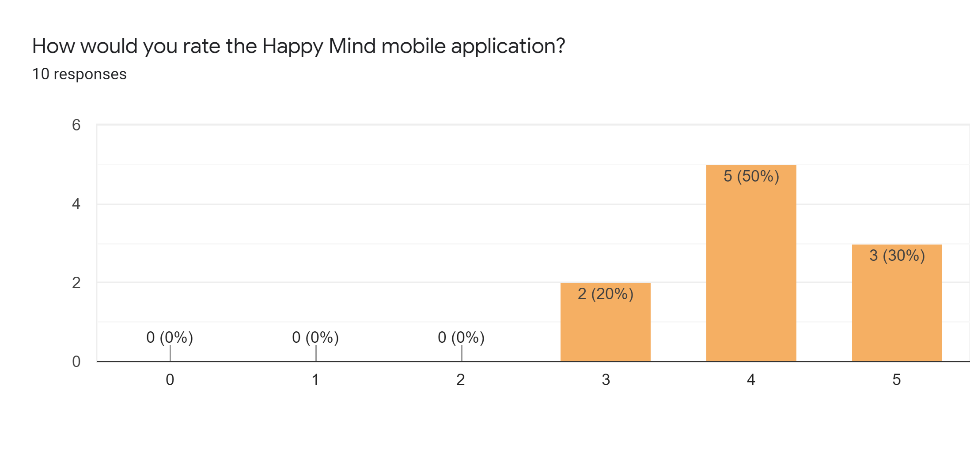
Figure 26 Feedback survey question 01 chart

Next question was set to identify for how many days the users have been using the application for. 50% of the users have been using the application for 7-8 days, which gives them plenty of time get an understanding of the functionality of the system. 40% have been using the application for 5-6 days. And only 10% have been using the application for 3-4 days which is somehow might not long enough to understand the application and get good results.
Figure 27 Feedback survey question 02 chart
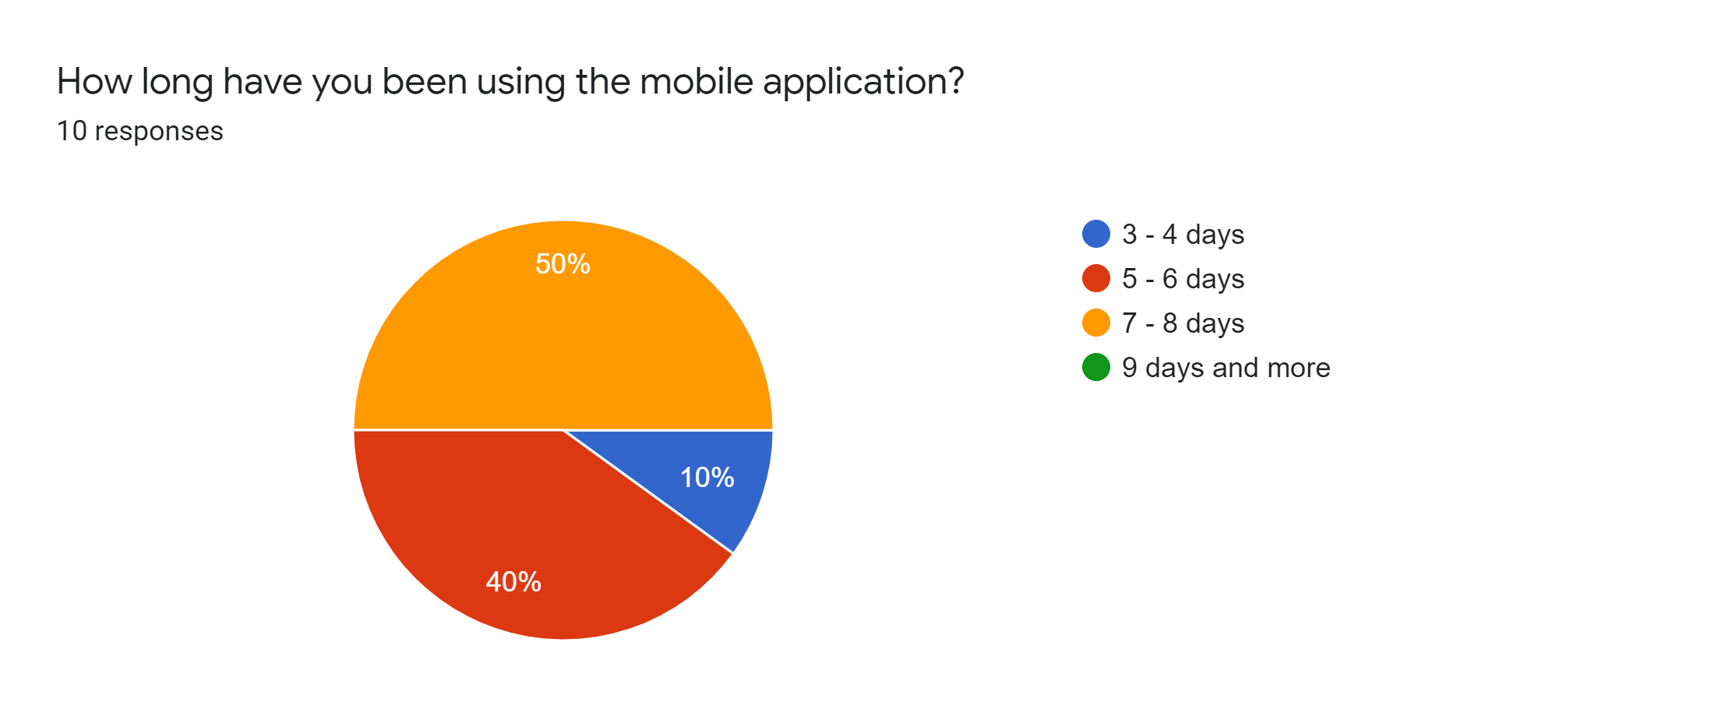

Next question focused on how long a user on average interact with the application per day. 80% of the users only interact for about 10-30 minutes with the application. Only a 30% of the users interact with the application for 30-40 minutes. This can be increased by adding more interesting features to the application.

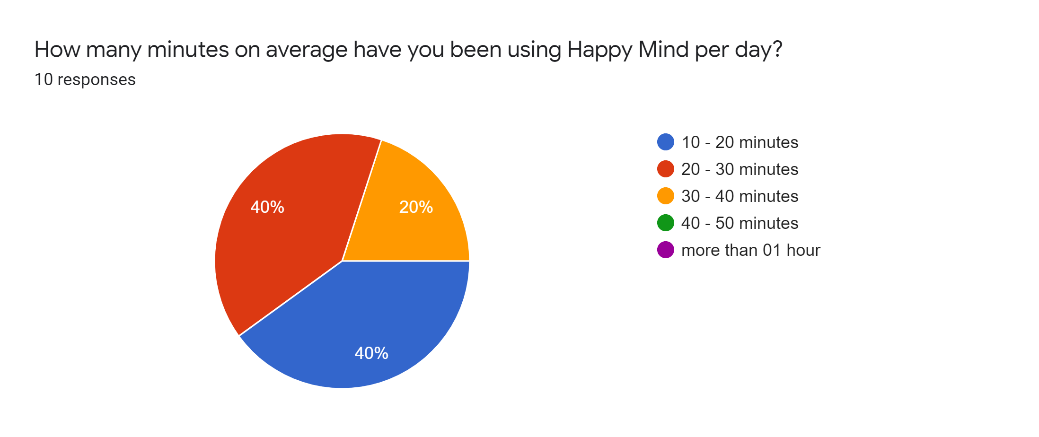
Figure 28 Feedback survey question 03 chart

As per the next question 50% of the users felt fully comfortable to trust the application to record their personal data. 40% was also comfortable to share data. And only one user out of the ten had doubts in sharing these data.
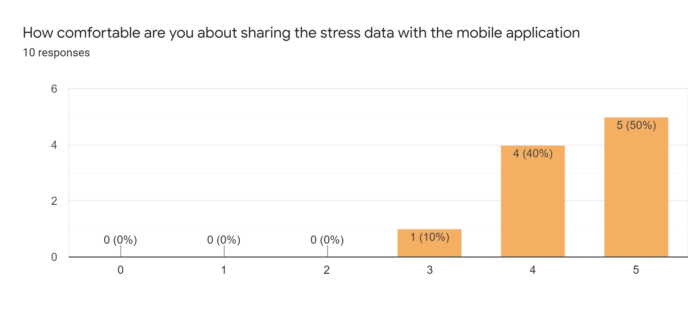
Figure 29 Feedback survey question 04 chart
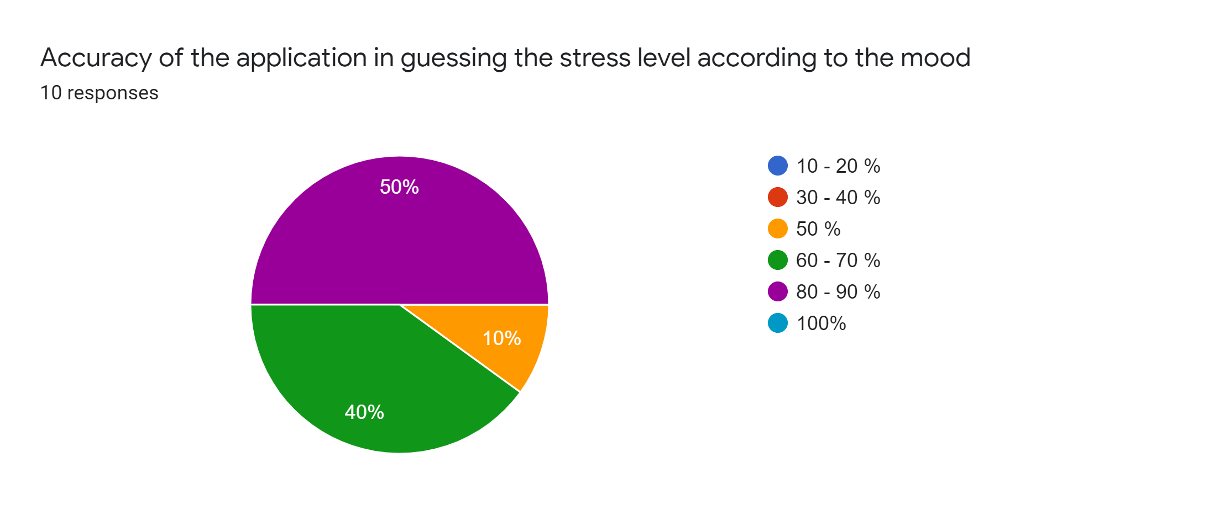
Next feedback question was to analyse the accuracy of the application in guessing the stress levels of the users. 80 – 90 % accuracy was seen by the 50% of the users. All the users gave above 50% accuracy to the system in guessing the stress levels which means application is accurate enough in analysing the stress levels.

Figure 30 Feedback survey question 05 chart
60% of the users agreed with the fact that stress relieving activities suggested by the application are helpful. 30% of the users strongly agreed with the said condition. Hence, it can be concluded that anti-stress activities of the application are useful and effective
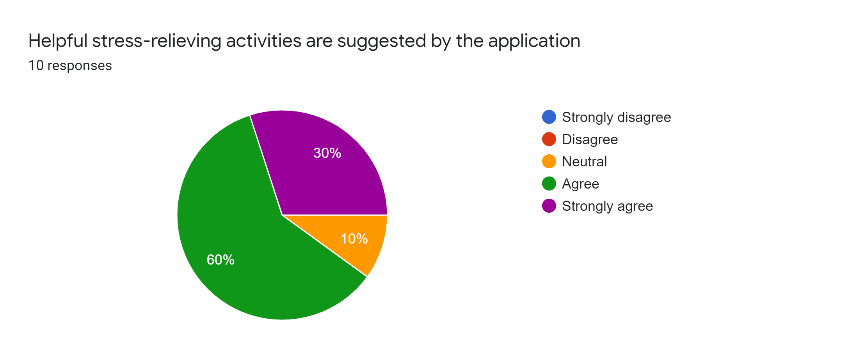
Figure 31 Feedback survey question 06 chart

80% of the users found themselves a considerable progress in managing stress while using the application. One of the users did not find any progress while one of them were not sure about the progress
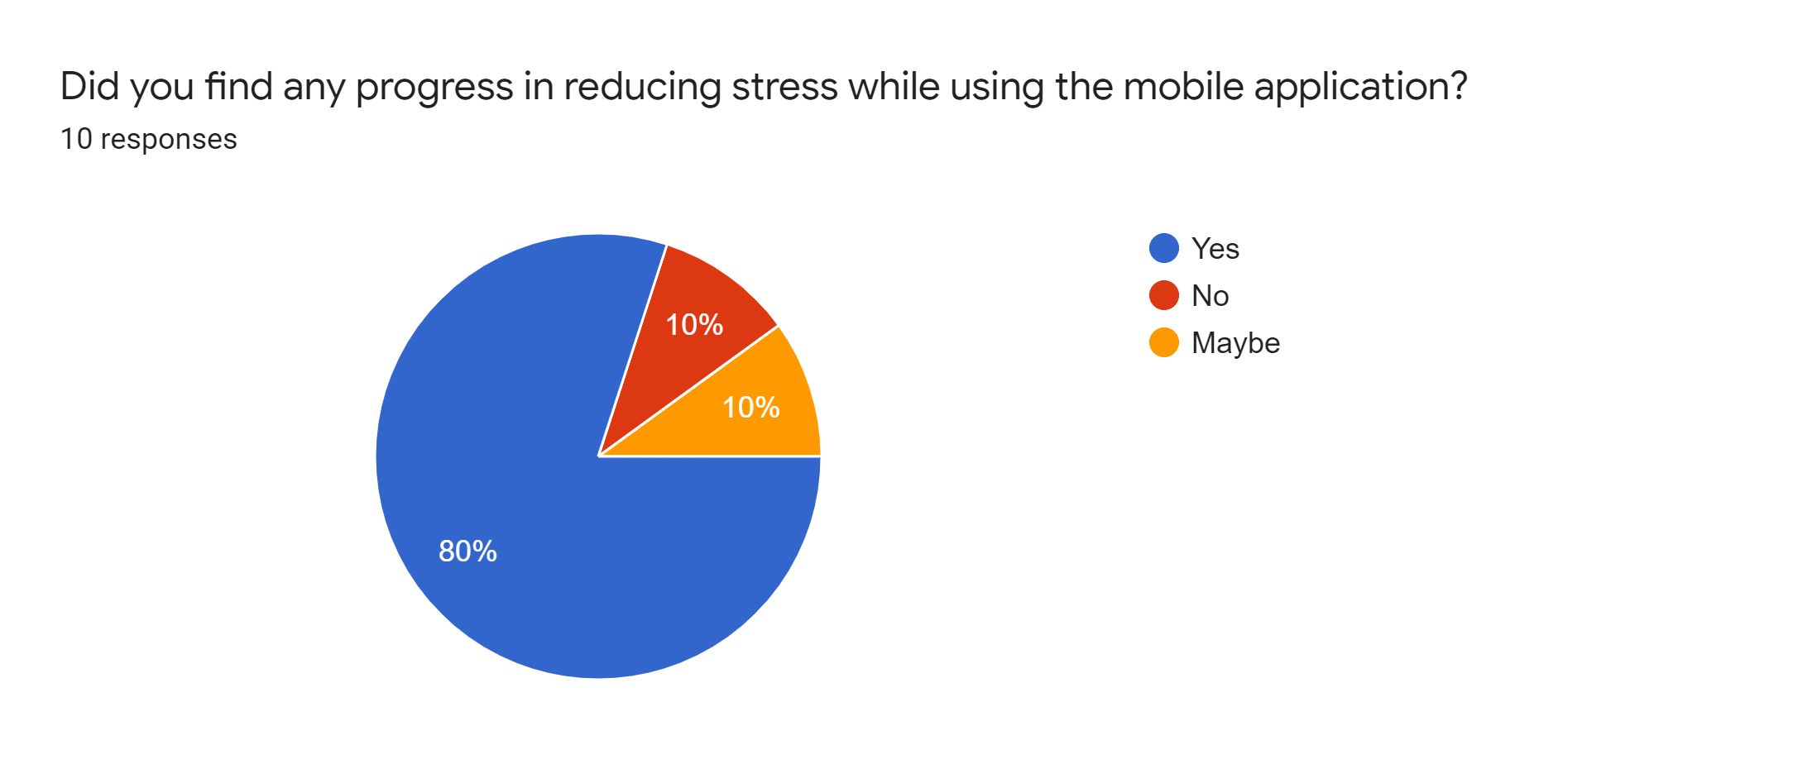
Figure 32 Feedback survey question 07 chart

Next question was about the interesting features of the application. Among those comments, usage of emojis were highlighted and the chatbot was also found interesting.

Table 2 User Feedback on system features

What are the interesting features of the mobile application?
# Usage of emojis to record the mood was interesting
# good interfaces
# emojis are cool
# chatbot is good
#chatbot is good
#activities are really helpful
#emojis are easy to understand
#breathing activity is effective
#dashboard stress levels seem accurate
#chatbot
#emojis
#cool emojis
#simple screens
#smooth application

Lastly users were requested to suggest any improvements to the system. Among the suggestions, it is clear that dashboard needs to be improved further. And the chatbot functionalities can be improved.

Table 3 User feedback on system improvements

What are the improvements that can be done to the mobile application?
# Need to improve the functionalities of the chatbot.
# Dashboard has to provide more data
# add more stress management activities
# need to improve the interfaces
# need to track more data to give stress levels
# need to develop the dashboard
# dashboard need improvements
# if the mood can be tracked by image processing it would be nice
# dashboard need more data

Chapter six: Conclusion

6.1 Reliability / Accuracy of the system

Since the application deals with the workplace stress accuracy of the application is a great concern. When considering the stress level suggesting accuracy application tends to have a 70 – 90 %
of accuracy. Reason for these values is that for analysing the stress levels some other factor also helpful other than the mood data. Therefore, accuracy percentages sometimes can drop to mid-levels. Another function in the system which affect the accuracy is stress relieving activity suggesting system. Accuracy of suggesting an effective anti-stress activity is around 60 – 90%. The reason for these high values is the application is proven to be smart than other applications since it understands the user quite efficiently.

6.2 Importance of the outcome

Workplace stress can be commonly identified among the employees in developed and developing countries. This health hazard threatens the physical and mental wellbeing of the user and also it is a threat to the industrial developments. Long term exposure to work stress can lead to severe mental damages in the employees. Since the Happy Mind mobile application provides a customized solution for the workplace stress, these threats can be minimized. Since the solution is a mobile application the tendency of it becoming popular among the employees is high. Since the users are educated about the stress that adds extra precaution in preventing the workplace stress. So, considered everything this mobile application provides a solution for a global threat.

6.3 Limitations of the system and Recommendations

Just like any other system, this mobile application also has some limitations.

- Only use English language in the system
- Application is android platform dependant
- App data is not backed up

Since the system only use English language it can be further developed to add several languages to the system. Then the user can select the preferred language and continue using the application.

Application can be enhanced to perform on the IOS and windows platforms which make the application platform independent.

Application data can be backed up to the google drive which make those data can be accessed from anywhere by the user. And also, in the event of the application needs to be reinstalled those backed up data can be used.

6.4 Future Work

As any other application, Happy Mind application can also be enhanced for a better user experience.

Currently mood of the user id tracked by using emojis. This function can be further enhanced to track the mood by image processing techniques. Using the front camera of the smartphone, user’s current mood can be analysed by a digital image processing model.

Already implemented chatbot function can also be developed further. A voice recognition feature can be added to the chatbot. Then the user can interact with the application by voice commands.

References

1. Colligan, T. and Higgins, E. (2006). Workplace Stress. Journal of Workplace Behavioral Health, 21(2), pp.89-97.

2. Beheshti, M. and Hajizadeh, R. (2013). Workload, occupational stress, and general health of female employees of public welfare centers. Journal of Occupational Health and Epidemiology, 2(4), pp.174-182.

3. Eremsoy, C., Çelimli, Ş. and Gençöz, T. (2005). Students under academic stress in a Turkish University: Variables associated with symptoms of depression and anxiety. Current Psychology, 24(2), pp.123-133.

4. Peter, R. and Siegrist, J. (2000). Psychosocial work environment and the risk of coronary heart disease. International Archives of Occupational and Environmental Health, 73(S1), pp.S41-S45.

5. KAWAKAMI, N. and HARATANI, T. (1999). Epidemiology of Job Stress and Health in Japan: Review of Current Evidence and Future Direction. INDUSTRIAL HEALTH, 37(2), pp.174-186.

6. Tangri R. Stress costs, Stress-cures. Britain:Trafford Publishing; 2003

7. Yadegarfar G, Alinia T, Gharaaghaji R, Allahyari T, Sheikhbagloo R. Study of Association between Job Stress and Cardiovascular Disease Risk Factors among Urmia Petrochemical Company Personell. Journal of Isfahan Medical School 2010; 28(112):645-60

8. Embriaco, N., Papazian, L., Kentish-Barnes, N., Pochard, F. and Azoulay, E. (2007). Burnout syndrome among critical care healthcare workers. Current Opinion in Critical Care, 13(5), pp.482-488.

9. Mathee, A., Oba, J. and Rose, A. (2010). Climate change impacts on working people (the HOTHAPS initiative): findings of the South African pilot study. Global Health Action, 3(1), p.5612.

10. Mansoor, M., Fida, S., Nasir, S. and Ahmad, Z. (2011). The Impact of Job Stress on Employee Job Satisfaction A Study on Telecommunication Sector of Pakistan. 2(3).

11. Mcgrath, J. (1976). Stress and behavior in organizations. In M.D. Dunnette (Ed), 1976 Handbook of Industrial and Organizational Psychology. Palo Alto, CA. Counseling psychological stress.

12. BEEHR, T. and NEWMAN, J. (1978). JOB STRESS, EMPLOYEE HEALTH, AND ORGANIZATIONAL EFFECTIVENESS: A FACET ANALYSIS, MODEL, AND LITERATURE REVIEW. Personnel Psychology, 31(4), pp.665-699.

13. thebmj. (1996). [online] Available at: https://www.bmj.com/content/313/7059/745.full [Accessed 4 Jan. 2020].
14. Mann, S. (2002). Organizational Stress: A Review and Critique of Theory, Research and Applications20024Cary L Cooper, Philip J Dewe and Michael P. O’Driscoll. Organizational Stress: A Review and Critique of Theory, Research and Applications. Sage Publications, 2001. 288 pages, ISBN: ISBN 0‐7619‐1480‐3 £47.00 (cloth), ISBN: ISBN 0‐7619‐1481‐1 £18.99 (paper). Leadership & Organization Development Journal, 23(5), pp.295-296.

15. Health and Safety Executive. (2004). Stress at work - HSE. [online] Available at: https://www.hse.gov.uk/stress/index.htm [Accessed 2 Jan. 2020].

16. Johnson, S., Cooper, C., Cartwright, S., Donald, I., Taylor, P. and Millet, C. (2005). The experience of work‐related stress across occupations. Journal of Managerial Psychology, 20(2), pp.178-187.

17. Yahaya, N., Yahaya, A., Tamyes, F., Ismail, J. and Jaalam, S. (2010). The Effect of Various Modes of Occupational Stress, Job Satisfaction, Intention to Leave and Absentism Companies Commission of Malaysia. Australian Journal of Basic and Applied Science.

18. Babatunde, A. (2013). Occupational Stress: A Review on Conceptualisations, Causes and Cure, 2(3).

Appendix A Project Poster

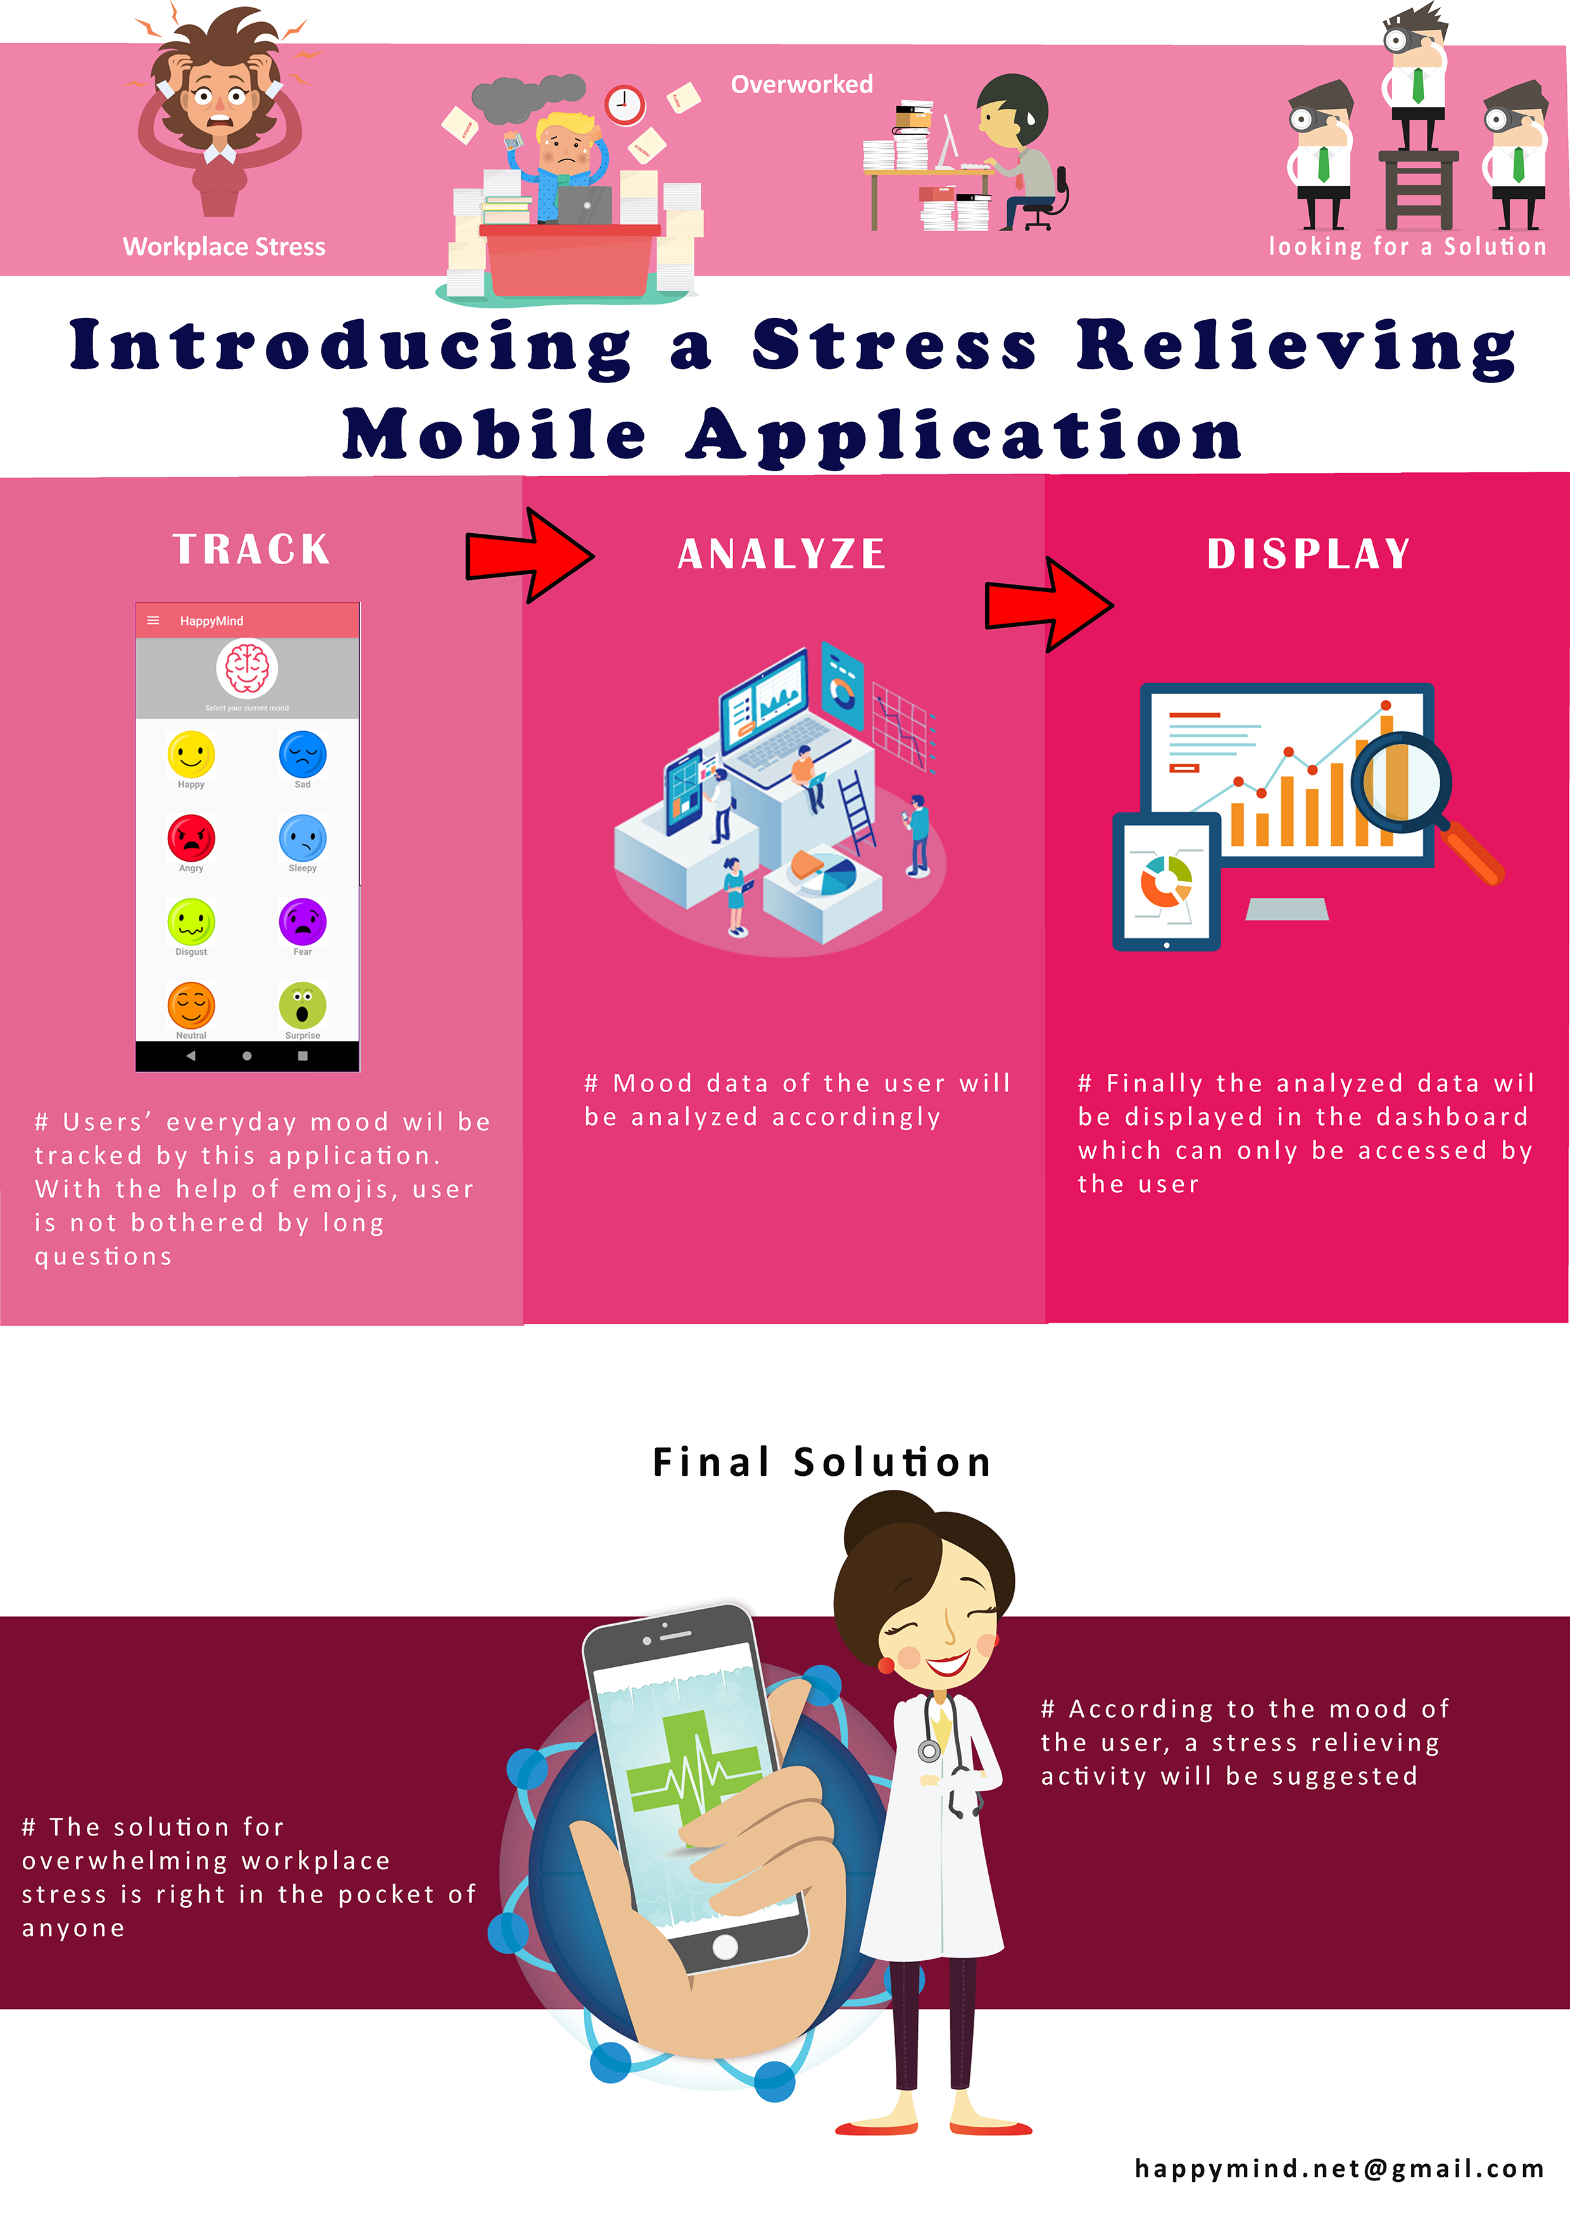
Figure 33 Project Poster

Appendix B UML Diagrams

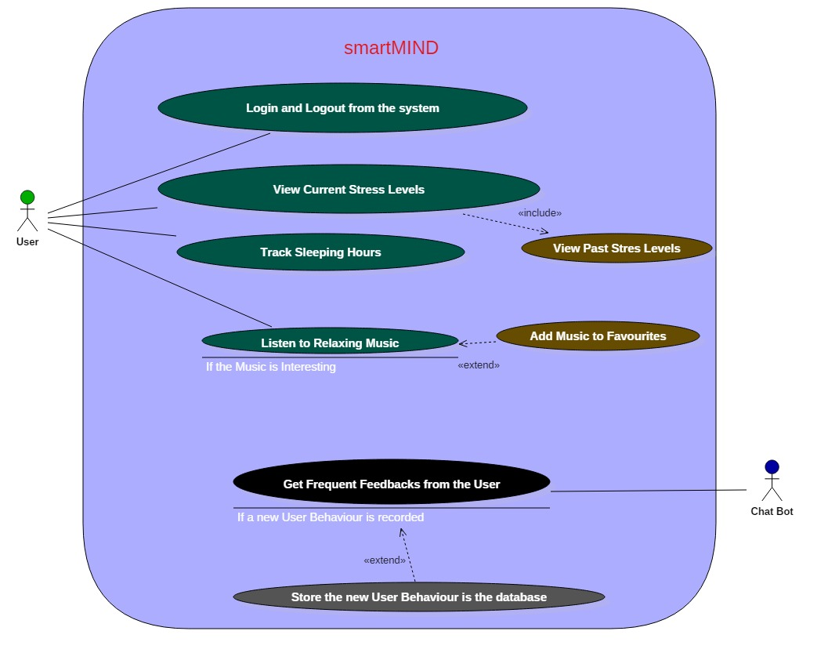
Figure 34 Use Case diagram of the system

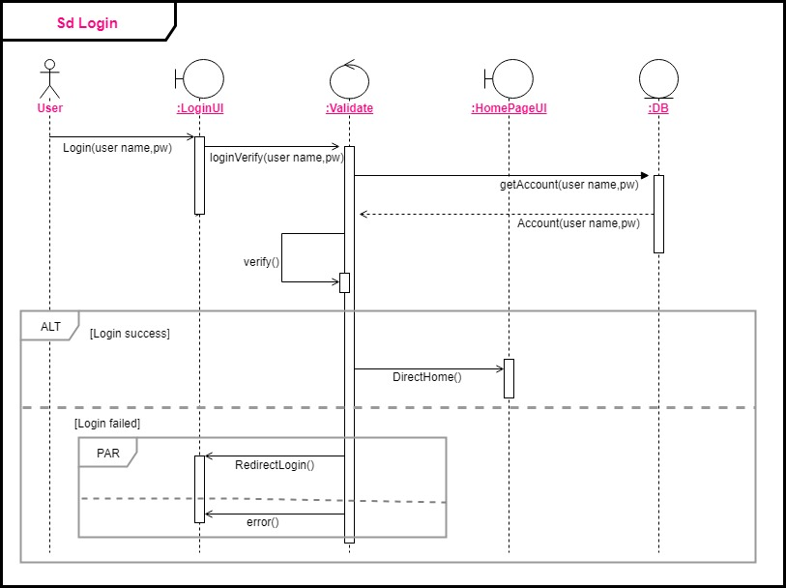

Figure 35 Sequence diagram for login function

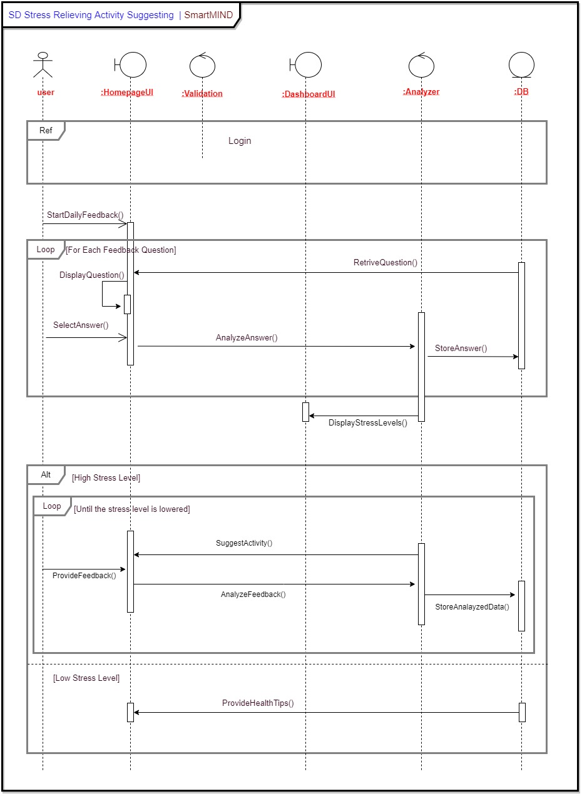
Figure 36 Sequence diagram for activity suggestion function

